Maria Cuellar
Assistant Professor
Department of Criminology
University of Pennsylvania
483 McNeil, 3718 Locust Walk, 483B
Philadelphia, PA, 19104
mcuellar@sas.upenn.edu
(646) 463-1883
April 3, 2024

To whom it may concern:

I am pleased to provide support for Stoney Forensic, Inc. relating to their proposed research that will investigate the use of combinations of very small particles to associate physical evidence with personal carrying locations. I will support this research as a consultant, providing statistical review and expertise.

Firstly, over the course of three years, I will be reviewing the technical deliverables (in an advisory role) for their quality and relevance with respect to statistical data analysis as applied to forensic science. This will include review of the research performance progress reports (every six months) as well as annual reports, publications, and presentations. This review effort is estimated at approximately 20-22 hours per year at a rate of $81.25/hr ($650 per 8-hour day) over the course of three years.

Secondly, I will be available for additional work during this period (at the same rate, up to 80 additional hours annually) as helpful or needed to directly oversee or conduct the statistical analyses and modeling described in the proposal.

I anticipate that I will be included as a co-author on research presentations and publications that are based on this work.

Best regards,
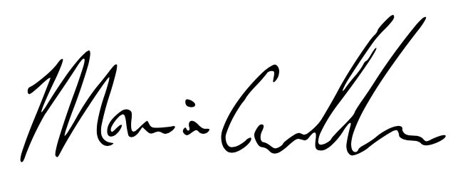

Maria Cuellar
Assistant Professor
Department of Criminology

